Linux for Devop
Olajide Kuti
Kutiolajide07@gmail.com Group 1
Assignment 5:
Linkedin post - https://www.linkedin.com/feed/update/urn:li:share:7485929332763246592/

Activities Performed
- Verified hostname
- Verified Ubuntu version
- Verified Nginx version
- Confirmed Nginx service was running

Result
The Ubuntu server was operational and Nginx was running successfully.
Screenshot 0
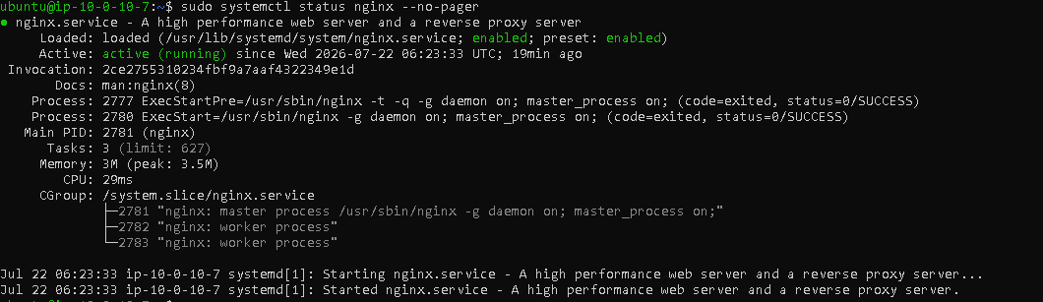
Task 1 – Get the Website Source Code
Downloaded the portfolio template from GitHub using wget, extracted the archive using unzip, and verified the project files. The portfolio template was successfully downloaded and extracted.
Screenshot 1
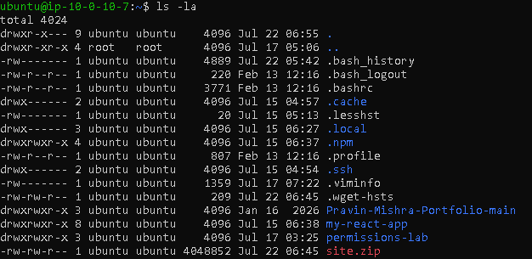

Task 2 – Add Ownership Proof (Anti-Copy Change)
Edited the website footer using Nano and added deployment ownership information.
Added: <p><strong>Deployed by:</strong> DMI Cohort 3 | Olajide Kuti | Group 1 | Week 3 | 22-07-2026</p>

Result
Ownership information was successfully embedded in the website footer.
Screenshot 2
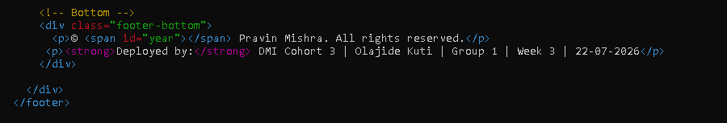
Task 3 – Deploy Website via Nginx
Removed the existing web content, copied the portfolio website to the Nginx web root, assigned the correct ownership and permissions, validated the Nginx configuration, and restarted the service.
sudo rm -rf /var/www/html/*
sudo cp -r ~/Pravin-Mishra-Portfolio-main/* /var/www/html/
sudo chown -R www-data:www-data /var/www/html
sudo chmod -R 755 /var/www/html
sudo nginx -t
sudo systemctl restart nginx
The website deployed successfully and the Nginx configuration test passed.
Screenshot 3
Retrieved the server's public IP address and accessed the deployed website through a web browser
Screenshot 4
Task 4 – Verify Website is live

Activities Performed
Retrieved the server's public IP address and accessed the deployed website through a web browser.
The website was publicly accessible, and the footer displayed the required deployment details.
Screenshot 5
Screenshot 6
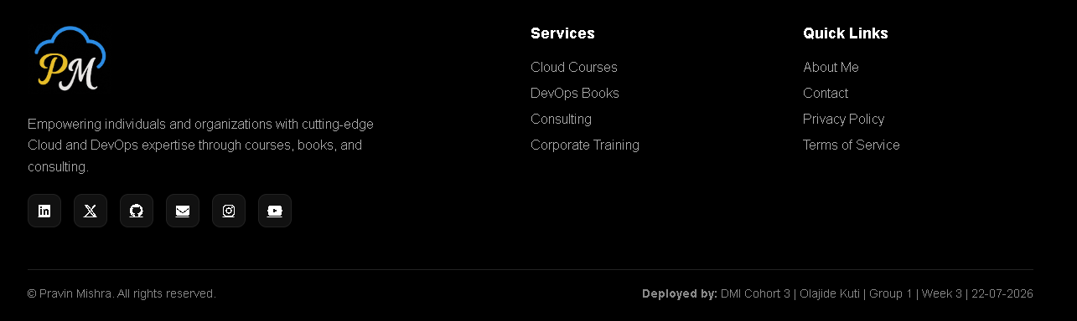
Task 5 – Mini Real DevOps Operational Check
Screenshot 7

Activities Performed
Verified:
- Nginx starts automatically
- Nginx configuration
- Local HTTP response
systemctl is-enabled nginx
sudo nginx -t
curl -I http://localhost

Result
- Nginx is enabled at boot.
- Configuration test passed successfully.
- Local HTTP request returned HTTP/1.1 200 OK.
Screenshot 8

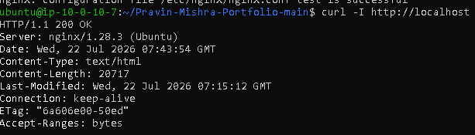
Challenges Encountered
During deployment, the website initially displayed an older React application instead of the portfolio website. After verifying the deployment files, confirming the Nginx configuration, and checking browser caching, the correct portfolio website became accessible through the public IP.
This troubleshooting exercise reinforced the importance of validating deployments from both the server and client perspectives.
Skills demonstrated
- AWS EC2 Management
- Ubuntu Linux Administration
- Nginx Web Server Configuration
- Static Website Deployment
- Linux File Permissions
- Linux Command Line
- Basic DevOps Troubleshooting
- Web Application Validation
Conclusion
This assignment successfully demonstrated the complete deployment lifecycle of a static website using Nginx on an Ubuntu EC2 instance. The website was configured, deployed, verified, and made publicly accessible. Operational checks confirmed that the Nginx service was functioning correctly and configured to start automatically after system reboot.
Public Website
http://35.178.80.88

Linkedin post - https://www.linkedin.com/feed/update/urn:li:share:7485929332763246592/

Completed another hands-on deployment exercise focused on Linux systems administration, web infrastructure, and deployment validation within an AWS environment.
For this implementation, I provisioned and configured an Ubuntu EC2 instance, deployed a static web application using Nginx, and executed end-to-end deployment validation. Verification was performed at both the application and network layers by confirming local service health (curl -I http://localhost) and validating external connectivity through the EC2 public endpoint. This ensured the web service was operational, correctly configured, and accessible to end users.
Key activities included:
- Deploying application content to the Nginx document root
- Managing Linux file ownership and permissions (www-data)
- Validating Nginx configuration before service restart
- Verifying HTTP availability locally and via the public endpoint
- Troubleshooting deployment inconsistencies using a structured validation approach, including configuration verification, HTTP response analysis, and client-side cache isolation
One of the more valuable aspects of this exercise wasn't the deployment itself, but the troubleshooting process. Identifying why an application appeared inconsistent between local and external access reinforced the importance of validating assumptions methodically before making configuration changes.
Although this was a controlled lab environment, the workflow closely mirrors the operational checks performed during production deployments and change implementation.
Public deployment:
🌐 http://35.178.80.88
I'm continuing to strengthen my expertise across Linux, AWS, Azure, Microsoft Security, and DevOps engineering through practical

Implementing and Validating a Static Web Deployment on AWS EC2 Using Nginx

Implementing and Validating a Static Web Deployment on AWS EC2 using Nginx
Completed another hands-on deployment exercise focused on Linux systems administration, web infrastructure, and deployment validation within an AWS environment.
For this implementation, I provisioned and configured an Ubuntu EC2 instance, deployed a static web application using Nginx, and executed a structured post-deployment validation process. Verification was performed at both the application and network layers by confirming local service health (curl -I http://localhost) and validating external connectivity through the EC2 public endpoint. This ensured the service was correctly configured, operational, and accessible to end users.

Key activities included
- Deploying application content to the Nginx document root
- Managing Linux ownership and permissions using www-data
- Validating the Nginx configuration before restarting the service
- Verifying HTTP availability through both local and public endpoints
- Troubleshooting deployment inconsistencies using a structured validation methodology, including configuration verification, HTTP response analysis, and client-side cache isolation
One of the most valuable aspects of this exercise wasn't simply deploying the application—it was the troubleshooting process. Investigating why the application initially appeared inconsistent between local and external access reinforced the importance of validating assumptions methodically before making configuration changes.
Although this was completed within a controlled lab environment, the workflow reflects the same validation practices used during infrastructure changes and post-deployment verification in production environments.
Post-deployment operational validation included:
- Configuration integrity
- Automatic service startup verification
- Local application health checks
- Public endpoint validation
- End-to-end service verification
🌐 Public deployment:
http://35.178.80.88
I'm continuing to strengthen my expertise across Linux, AWS, Azure, Microsoft Security, and DevOps through practical implementation and hands-on engineering.

